AUTOMATIC FIRE EXTINGUISHER ROBOT

Akshat Gupta

Department of Computer Science & Engineering

chandigarh University

Chandigarh, India

[akshatg989@gmail.com](mailto:akshatg989@gmail.com)

Abstract— **Automatic Fire Extinguisher Robot can save life of many people who loss their life due to many reasons like fire take place in small space or fire fighter can't reach on time and many more other reasons. The prime objective of this research paper is to creates the model that can extinguish the fire and save the life of people from impossible or unthinkable areas. It consists of GSM technology which give message or call alert to nearest firefighter. The Robot is lined with calcium silicate forums which can be able to withstanding very excessive temperatures. It consists of high-level flame detector which detected flame and immediate responds to it. It fully automatic and also manually control by anyone its whole controlling done through Arduino and code input in Arduino put in C or C++ programming language. It also consists of MQ2 sensor which detected the smoke which comes from fire and also respond to it after detecting the smoke.**

***Keywords- Automatic fire extinguisher robot, Arduino, GSM Sensor, MQ2 Sensor, Flame Sensor.***

1. INTRODUCTION

Nowadays, fire is a not unusual place critical hassle confronted with the aid of using international locations everywhere in the world. While inflicting casualties, it's going to additionally convey sure assets losses and damaging sociopolitical effects. According to records from the China Commercial Fire and Safety Association in 2019, a complete of 233,000 fires had been mentioned throughout the country, 1,335 humans died, and direct assets losses reached 3.612 billion yuan. Compared with 2018, the numbers of fires and assets losses were decreased with the aid of using 4% and 1.9%, respectively. Among them, the variety of fires as a result of electric short-circuit growing older and different motives is majority. Figure 1 suggests the state of affairs of great fires withinside the beyond thirteen years. In addition, with the non-stop increase of population and economy, high-upward push homes also are increasing, and the variety of fires has improved with the aid of using 5.8% in comparison with the preceding year. Therefore, high-upward push homes have come to be the focal point and problem of fire prevention. The strain and problem of city fire prevention and manage will preserve to increase, and dangers have to be anticipated earlier and preventive measures have to be studied earlier. Detecting the incidence of fire with inside the first time and tracking fire in actual time can play an essential function in decreasing the lack of lifestyles and assets of human [1].

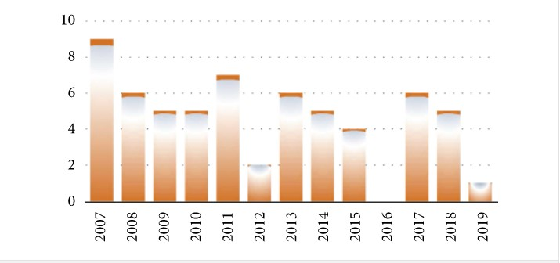

Fig 1: Fire accident in each year (in lakhs)

With the improvement of Internet of Things (IoT) and computer science era, the software of IoT to fire alarms can appropriately find the fire factor and has the traits of actual-time tracking, fire tracking, on line upgrades, and handy maintenance. Many nations have additionally performed a whole lot of studies on wi-fi verbal exchange era programs to indoor fire protection. Many scientists and researchers studied the sensor like fire sensor, GSM technology, MQ2 senor for smoke detection are very useful and detected the fire in actual time without any error. When the statistics of GSM and MQ2 sensor are seen by scientists by doing various test there is minute level of error shown. Scholars along with Zia Ur Rahman followed GSM Sensor Network to build up correct environmental statistics via way of means of sensor nodes along with temperature, smoke, and specific fuel line concentrations and ship those statistics to base stations linked to the ground [2].

Based at the above issues, this paper chooses LoRa as verbal exchange module. The module has lengthy distance and occasional energy intake traits. The device is split into 3 parts: node, gateway, and cloud server. The nodes and gateways are deployed in a community structure. This device is deployed in city indoor buildings, big warehouses, or big factories and set up in ventilated and smooth-to-stumble on places along with partitions and ceilings. Compared with different solutions, this answer differs in the one’s terminal nodes are smooth to deploy [3]. Moreover, the deployed nodes have an extended provider lifestyles and via sensor filtering and weighted fusion set of rules to choose whether or not a fire occurs but due to low transmission and high in cost in not easily affordable buy many of human. This problem is fix by our research our product has high range and low in cost which can be affordable by normal people and also adapt by many countries which don’t have budget to buy expensive structure.

1. LITERATURE SURVEY
2. Rutuja Jadkar et al. [4]: It can be operated and controlled by remote user and has firefighting capability after detection at source of fire. It is equipped with a monitoring system and operates through a wireless communication system. The fire detection system is designed using sensors mounted on firefighter robots. The robot is controlled. The Android mobile phone platform developed by Google using the Android application independently has gained popularity. Its power among software developers.
3. Abdul Waris Memon et al. [5]: A robot is a device that performs a human function or behaves like a human. It requires expertise and skills Complex programming to design. Many sensors and motors were used to design firefighter robots. First user Send the robot to the affected area to get a live picture of the field with the help of mobile camera via Wi-Fi using IP camera. Application for Laptop If there is a sign of fire in the picture, then the user confirms the robot in that particular direction.
4. S. Kavitha et al. [3]: Fighting is a necessary and very dangerous task against flames. This plan is being implemented. Automatic as well as manual. Uses this project ARM7. In areas such as nuclear power plants, Petroleum refineries, gas tanks, chemical plants and others Large-scale industries, the majority of fire incidents Occurs, resulting in complicated situations. More numbers People have lost their lives due to such incidents. We are installing a Wi-Fi module (Node MCU) for mobile. Communication for fire detection and many more.
5. Pushpendra Kumar et al. [4]: Automation has a big role to play in this century in this industrial and domestic world. Is an arrangement of Organizing different elements, direct, sense and? Commands oneself to achieve a particular and desired result. Electric in the "Automatic Firefighting Robot" project. Thermostat technology for 24-hour fire control. This The project is cost effective with an Explorer application and it will show the best result and it can be used a lot in Industrial, commercial and domestic purposes. This system involves synchronizing at different devices.
6. Akshay Deshmukh et al. [5]: A robot capable of fighting simulation. When domestic fires will be designed and built. It should be able to navigate independently through the model floor. Plan while actively scanning for flames. The robot can also act as a path guide in general and as a fire. Emergency Extinguisher Robots designed to search for fire can one day work with it before it gets out of control and this help firefighters greatly reduce the risk of injuries to victims.
7. C. Sevanth et al. [6]: In industries dangerous accidents will occur as a result of leakage of houses, fire and flammable gases. There are many potential fires in an industry or anywhere. Remote area Firefighting Robot is a newly developed design where its function is to reduce the risk of firefighter in dangerous situations. Firefighters must be able to reach fires quickly and extinguish fires safely, preventing further damage and minimizing casualties. This technology is finally more efficient and effective firefighting and firefighting methods.
8. MONISHA.A et al. [7]: The firefighting robot works on behalf of humans in a dangerous area. This system is used to protect human lives. Around globe many fire accidents occur and happen every time our goal is to develop a firefighting robot that helps society and protect them from fire accidents. Robots help rescue and help people by prescribing emergency medicine. Assistance for a person injured in a fire accident.
9. METHODOLOGY

System designing of robot consist both hardware and software approach hardware as well as software bot approach are very important for the robot. This robot consists of several type of sensor and component which are as:

1. FLAME SENSOR: this sensor basically designs for detecting as well as responding to the even a small amount of flame and fire. It detects the fire with 5 flame sensor which are arranged with 30 degrees. Detection range is 700 – 1100 nm.
2. GSM MODULE: A GSM modem or GSM module is a hardware tool that makes use of GSM cell phone generation to offer an information hyperlink to a faraway network. From the view of the cell tele cell smartphone network, they're basically same to an normal cell telecall smartphone, such as the want for a SIM to perceive themselves to the network.
3. GAS SENSOR: Gas Sensor (MQ2) module is beneficial for fuel line leakage detection (in domestic and industry). It can discover flammable fuel line and smoke. The output voltage from the Gas sensor will increase whilst the attention of fuel line. Sensitivity may be adjusted through rotating the potentiometer.
4. MOTOR DRIVER: L293 is an included chip (IC) that allows us to force a DC motor in both route and additionally manipulate the velocity of the motor. The L293D is a sixteen pin IC, with eight pins on every side, permitting us to govern the motor. Its manner that we will use a unmarried L293D to run up to 2 DC motors. L293D include H-bridge circuit. H-bridge is the best circuit for converting polarity throughout the weight related to it.
5. RELAY MODULE: A strength relay module is an electrical transfer this is operated with the aid of using an electromagnet. The electromagnet is activated with the aid of using a separate low-strength sign from a micro controller. When activated, the electromagnet pulls to both open or near an electrical circuit.
6. DC-DC BUCK CONVERTER: LM2596 DC-DC Buck Converter Step Down Module LM2596 Power Supply is a step-down(buck) switching regulator, able to riding a three-A load with amazing line and cargo regulation. These gadgets are to be had in constant output voltages of three. Three V, five V, 12 V, and an adjustable output version.
7. SERVO MOTER: Micro Servo Motor SG90 is a tiny and light-weight server motor with excessive output power. Servo can rotate about a hundred and eighty degrees (ninety in every direction), and works similar to the same old sorts however smaller. You can use any servo code, hardware or library to govern those servos.
8. ARDUINO: Arduino is an open-supply electronics platform primarily based totally on easy-to-use hardware and software. Arduino forums are capable of examine inputs - mild on a sensor, a finger on a button, or a Twitter message - and flip it into an output - activating a motor, turning on an LED, publishing something online.
9. DESIGN

DFD Diagram: -

A data flow diagram is a graphical view of how data is processed in a system in terms of input and output. The Data flow diagram (DFD) contains some symbol for drawing the data flow diagram

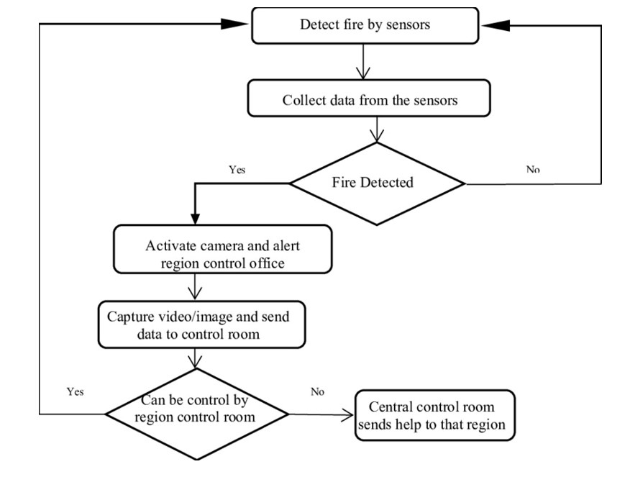

Block Diagram: -

It is a diagram of system in which principal parts of the robot represent by bock by connecting lines that show relationship of each block.

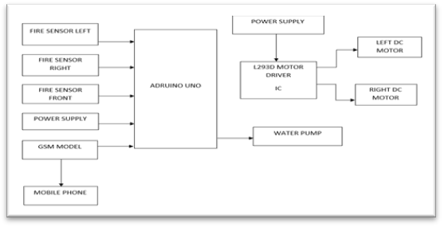

Circuit Diagram: -

It is graphical representation of circuit diagram of robot in which picture of every component of robot are connected as same as in robot

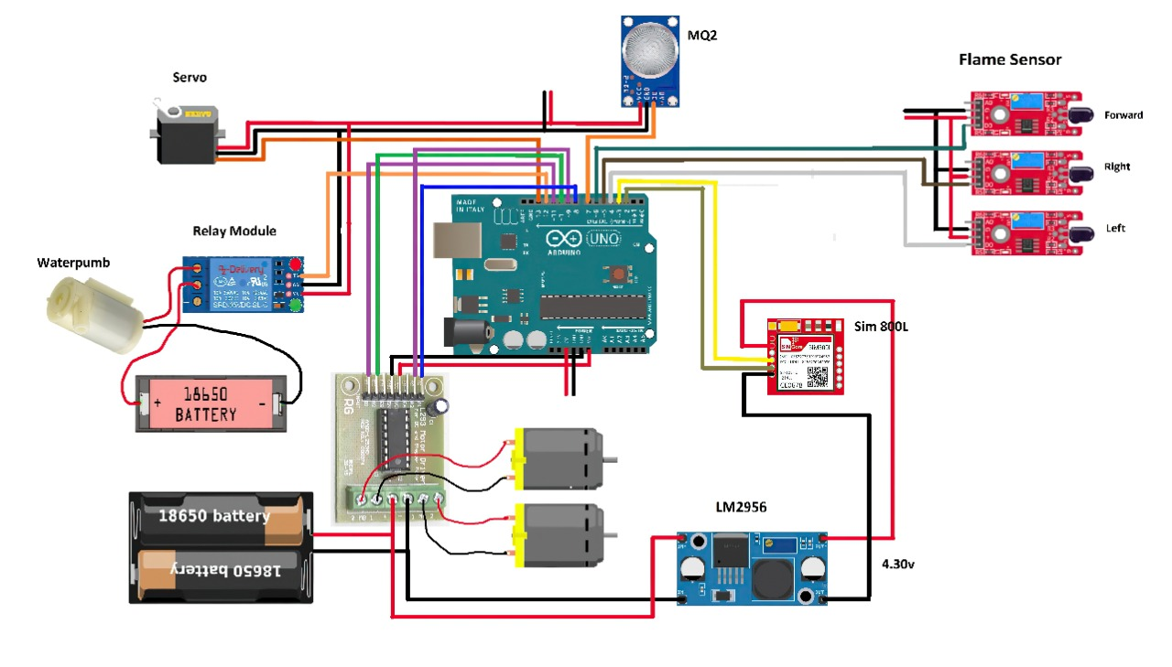

1. RESULT

In this paper the prototype module is constructed with the aid of using the use of exclusive aspect Arduino, GSM Module, Smoke detector, Fire detector Wires, water sprayer and Jumper cords and bread Board. The block diagram indicates with exclusive aspect. Few exams had been performed to look at the system’s performance. The SMS acquired with the aid of using the user. The synthetic hearthplace is lit on the centre factor in an enclosed environment (11 × 10 × 10 ft) in which the temperature and smoke detectors had been placed. The sign from smoke detector is received inside forty-five seconds even as it took round four mins forty seconds to get the sign from temperature sensor. This is due to the fact the temperature growth takes a widespread time even as the herbal move of smoke takes much less time. To affirm this statement the exclusive depth of fire became lit at exclusive area withinside the enclosed environment. It recorded that the time for the sign from the smoke detectors became virtually dependent (from 20 seconds to 40 min) at the area of the hearthplace even as the time for the sign from temperature sensor became of the order of five mins. This justifies using each the sensors. When signal receive from both sensors water sprayer activated extinguish fire on affected area.

1. CONCLUSION

# The evolved prototype on these paintings is made for a person to govern the hearthplace alarm machine remotely. This enables the person if he/she isn't withinside the constructing or maybe ignorant of emergency condition. The use of this prototype will keep away from the unpredictable scenario or any important scenario from taking place withinside the residential regions without cognizance of the resident. The domestic alert machine is determined to be purposeful through triggering the hearthplace extinguisher. The use of coupled sensor of temperature sensor and smoke detector become observed to be extra suitable than using best one in every of them. Though the prototype become capable of extinguish the hearthplace however the portability may be drastically improved through a green assimilation of the one-of-a-kind modules. This machine needs to additionally take care that every module of it could be without problems changed through a higher sensor and device with up-to date technology. The microcontroller may be programmed with the touch variety of nearby government of hearthplace brigade. The proposed prototype may be implemented in clever cities (e.g., houses, hostels, motel industries, factories) due to its flexibility and ease in handling.

# REFERENCES

1. Wikipedia
2. W. Yunlong, “Current status and improvement of fire protection supervision of high-rise buildings in my country,” *Green Building Materials*, vol. 309, no. 9, pp. 165-166, 2021.View at: [Google Scholar](https://scholar.google.com/scholar_lookup?title=Current%20status%20and%20improvement%20of%20fire%20protection%20supervision%20of%20high-rise%20buildings%20in%20my%20country&author=W.%20Yunlong&publication_year=2021)
3. Tzounis, N. Katsoulas, T. Bartzanas, and C. Kittas, “Internet of Things in agriculture, recent advances and future challenges,” *Biosystems Engineering*, vol. 164, pp. 31–48, 2017.View at: [Publisher Site](https://doi.org/10.1016/j.biosystemseng.2017.09.007) | [Google Scholar](https://scholar.google.com/scholar_lookup?title=Internet%20of%20Things%20in%20agriculture,%20recent%20advances%20and%20future%20challenges&author=A.%20Tzounis&author=N.%20Katsoulas&author=T.%20Bartzanas&author=&author=C.%20Kittas&publication_year=2017)
4. X. J. Xing, J. C. Song, L. Y. Lin, M. Q. Tian, and Z. P. Lei, “Development of intelligent information monitoring system in greenhouse based on wireless sensor network,” in *Proceedings of the 2017 4th International Conference on Information Science and Control Engineering (ICISCE)*, pp. 970–974, IEEE, Changsha, China, July 2017.View at: [Publisher Site](https://doi.org/10.1109/icisce.2017.205) | [Google Scholar](https://scholar.google.com/scholar_lookup?title=Development%20of%20intelligent%20information%20monitoring%20system%20in%20greenhouse%20based%20on%20wireless%20sensor%20network&author=X.%20J.%20Xing&author=J.%20C.%20Song&author=L.%20Y.%20Lin&author=M.%20Q.%20Tian&author=&author=Z.%20P.%20Lei)
5. L. Yunhong and Q. Meini, “The design of building fire monitoring system based on zigbee-wifi networks,” in *Proceedings of the 2016 Eighth International Conference on Measuring Technology and Mechatronics Automation*, pp. 733–735, IEEE, Macau, China, March 2016.View at: [Publisher Site](https://doi.org/10.1109/icmtma.2016.180) | [Google Scholar](https://scholar.google.com/scholar_lookup?title=The%20design%20of%20building%20fire%20monitoring%20system%20based%20on%20zigbee-wifi%20networks&author=L.%20Yunhong%20&author=Q.%20Meini)
6. X. P. Shen, X. Wang, and M. Jia, “Design and implementation of traffic information detection equipment based on Bluetooth communication,” in *Proc. IEEE Inf. Technol. Netw. Elect. Autom. Control Conf.*, pp. 1595–1601, IEEE, Chengdu, China, December 2017.View at: [Publisher Site](https://doi.org/10.1109/itnec.2017.8285063) | [Google Scholar](https://scholar.google.com/scholar_lookup?title=Design%20and%20implementation%20of%20traffic%20information%20detection%20equipment%20based%20on%20Bluetooth%20communication&author=X.%20P.%20Shen&author=X.%20Wang&author=&author=M.%20Jia)
7. S. Basu, S. Pramanik, S. Dey, G. Panigrahi, and D. K. Jana, “Technology, Fire Monitoring in Coal Mines Using Wireless Underground Sensor Network and Interval Type-2 Fuzzy Logic Controller,” *International Journal of Coal Science & Technology.*, vol. 6, no. 2, pp. 274–285, 2019.View at: [Publisher Site](https://doi.org/10.1007/s40789-019-0244-7) | [Google Scholar](https://scholar.google.com/scholar_lookup?title=Technology,%20Fire%20Monitoring%20in%20Coal%20Mines%20Using%20Wireless%20Underground%20Sensor%20Network%20and%20Interval%20Type-2%20Fuzzy%20Logic%20Controller&author=S.%20Basu&author=S.%20Pramanik&author=S.%20Dey&author=G.%20Panigrahi&author=&author=D.%20K.%20Jana&publication_year=2019)
8. X. Zhang, J. Du, C. Fan, D. Liu, J. Fang, and L. Wang, “A wireless sensor monitoring node based on automatic tracking solar-powered panel for paddy field environment,” *IEEE Internet of Things Journal*, vol. 4, no. 5, pp. 1304–1311, 2017.View at: [Publisher Site](https://doi.org/10.1109/jiot.2017.2706418) | [Google Scholar](https://scholar.google.com/scholar_lookup?title=A%20wireless%20sensor%20monitoring%20node%20based%20on%20automatic%20tracking%20solar-powered%20panel%20for%20paddy%20field%20environment&author=X.%20Zhang&author=J.%20Du&author=C.%20Fan&author=D.%20Liu&author=J.%20Fang&author=&author=L.%20Wang&publication_year=2017)
9. M. Iqbal, A. Y. M. Abdullah, and F. Shabnam, “An application based comparative study of LPWAN technologies for IoT environment,” in *Proceedings of 2020 IEEE Region 10 Symposium (TENSYMP)*, pp. 1857–1860, Dhaka, Bangladesh, 2020.View at: [Publisher Site](https://doi.org/10.1109/TENSYMP50017.2020.9230597) | [Google Scholar](https://scholar.google.com/scholar_lookup?title=An%20application%20based%20comparative%20study%20of%20LPWAN%20technologies%20for%20IoT%20environment&author=M.%20Iqbal&author=A.%20Y.%20M.%20Abdullah&author=&author=F.%20Shabnam)
10. G. Roque and V. S. Padilla, “LPWAN based IoT surveillance system for outdoor fire detection,” *IEEE Access*, vol. 8, pp. 114900–114909, 2020.View at: [Publisher Site](https://doi.org/10.1109/ACCESS.2020.3003848) | [Google Scholar](https://scholar.google.com/scholar_lookup?title=LPWAN%20based%20IoT%20surveillance%20system%20for%20outdoor%20fire%20detection&author=G.%20Roque%20&author=V.%20S.%20Padilla&publication_year=2020)
11. D. Patel and M. Won, “Experimental study on low power wide area networks (LPWAN) for mobile Internet of Things,” in *Proceedings of the 2017 IEEE 85th Vehicular Technology Conference (VTC Spring)*, pp. 1–5, Sydney, NSW, Australia, June 2017.View at: [Publisher Site](https://doi.org/10.1109/vtcspring.2017.8108501) | [Google Scholar](https://scholar.google.com/scholar_lookup?title=Experimental%20study%20on%20low%20power%20wide%20area%20networks%20(LPWAN)%20for%20mobile%20Internet%20of%20Things&author=D.%20Patel%20&author=M.%20Won)
12. T. Defeng, L. Shixing, X. Wujun, and Z. Yongming, “A fire monitoring system in ZigBee wireless network,” in *Proceedings of the 2010 International Conference on Cyber-Enabled Distributed Computing and Knowledge Discovery*, pp. 48–51, IEEE, Huangshan, China, October 2010.View at: [Publisher Site](https://doi.org/10.1109/cyberc.2010.19) | [Google Scholar](https://scholar.google.com/scholar_lookup?title=A%20fire%20monitoring%20system%20in%20ZigBee%20wireless%20network&author=T.%20Defeng&author=L.%20Shixing&author=X.%20Wujun&author=&author=Z.%20Yongming)